ARRL RADIOGRAM INSTRUCTIONS

The ARRL Radiogram is the official form used by radio operators on the National Traffic System (NTS). It can also be used on emergency radio nets when another specific form is not required.

ARRL Radiogram – Preamble

The Preamble shall include:
- Number (number of message in sequence for each station)
- Precedence (Emergency, Priority, Welfare or Routine)
- Station of Origin (first amateur handler or tactical call sign)
- Check (number of words/groups in message body text only)
- Place of Origin (city and state)
- Time filed (in 24 hour clock)
- Date (month/day/year)

The box marked HX is for handling instructions. These will not be used for messages on the emergency net.

ARRL Radiogram – Precedence

The radiogram has four levels of precedence:
- EMERGENCY: This is a message reporting a life or death situation that requires an immediate response. EMERGENCY messages have priority over all other traffic on the net. A station with an EMERGENCY message may break into a net at any time to send their message.
- “P” – Priority: These are important messages that have a specific time limit and will include most official traffic that is not emergency precedence.
- “W” – Welfare: These are messages that inquire about the health and welfare of an individual or are a response to a health and welfare inquiry.
- “R” – Routine: All messages that are not one of the above priorities. These messages will be handled last, or not at all if frequencies are busy.

ARRL Radiogram – Check

The box for “check” is used to designate the total words/groups in the body of the message. This allows the receiving station to determine if they have received the entire message.

A telephone number is handled as, and counted as, three groups (i.e. 707 555 2121).

The “X” (for X-RAY or a period) is also counted as a group.

The signature is a separate box and is not counted as one of the 25-word groups in the message.

ARRL Radiogram – Address

If the message is between emergency stations (EOC, medical facilities, shelters, etc.), the tactical call sign is sufficient information for the “TO” and “RECEIVED” addresses.

If the message is a health and welfare message and is directed to a specific person, all of the “TO” information should be completed. An email address can be substituted for the telephone number
]=
ARRL Radiogram – Body of Message

Example of a health and welfare message with a check count of 22.

Robin am fine at Willits____
shelter x will call when ____
phone restored x call Michelle__
707 555 2121 let her __
know x _______ ________ ________

The signature box can contain any identifying information for the party sending the message (i.e. Mike, Brother John, Rod parcel 5, etc.)

ARRL Radiogram – Simplex Relay

The origination station completes the Radiogram and fills in the “SENT” box with the station call sign of the first relay station.

The first relay station copies the Radiogram and enters the following information.
Their call sign in the “received by” box, the sending station in the “REC’D” box and the station they are sending to in the “SENT” box.

The only information that will change as the message is relayed are the message number, received by, received from and sent to boxes.

Each succeeding station does the same until the message arrives at the “TO” addressee.

ARRL Radiogram – Simplex Relay Originator
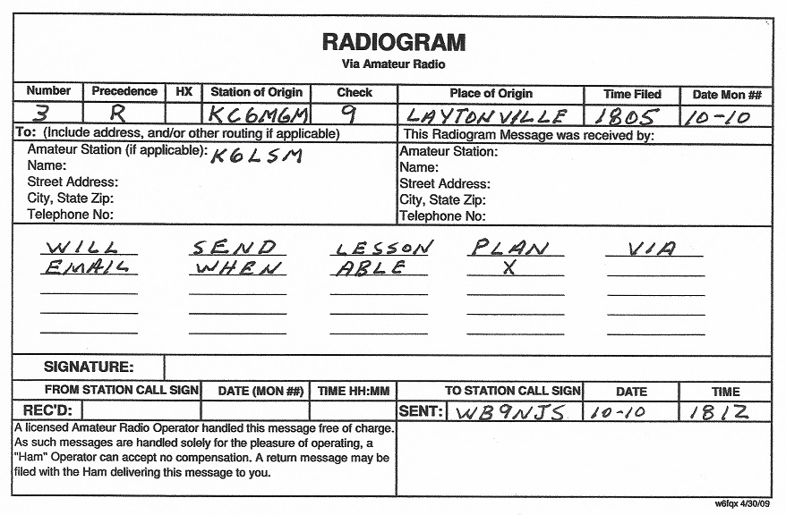

ARRL Radiogram – Simplex Relay First Relay
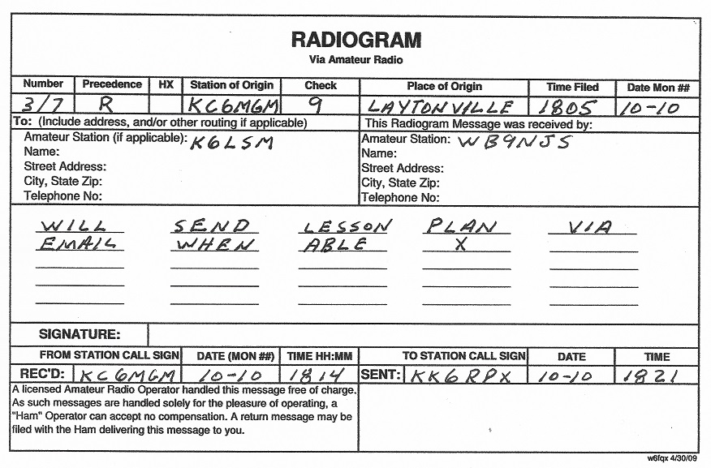
ARRL Radiogram – Simplex Relay Second Relay
